8/5/2022

Sumit Mishra

SIC: 190310286



**Project - 04**

Migrate a database server from on-premises to AWS.

# Create a RDS server on AWS using the console.

# Create an EC2 instance (Amazon Linux with ms SQL server) using the console.

# Configure SQL Server on the EC2 instance.

1. While the server was launching, I created and attached an extra EBS volume to store the Database data.
2. Connected to the EC2 instance using xShell and typed the following commands for configuring the SQL server.
   1. Switched user to super user.
   2. Stopped the SQL server.
   3. Ran an mssql-conf script to reset the SA password.
   4. Formatted the volume to ext4 type.
   5. Created a directory name ‘SQLServerData’.
   6. Mounted the directory into the attached volume.
   7. Attached some permissions to the directory.
   8. Changed some settings using some commands to enable the SQLServerData director as the default data directory.
   9. Restarted the ms-sql service.
3. Connected the ms-sql server using the Microsoft SQL Server Management Studio.
   1. Provide username as sa.
   2. Provide password for the system server.
   3. Select SQL server authentication.
   4. Click connect.
4. Created a database and some schema inside using the Microsoft SQL Server Management Studio.
   1. Created a database using ‘Create Database’ Command.
   2. Created a sample table inside the database.

* 1. Inserted some records into it.

# Migrating the on-premises database to AWS using DMS service.

1. Created a replication instance for migration of Databases using port number 1433 for mssql.

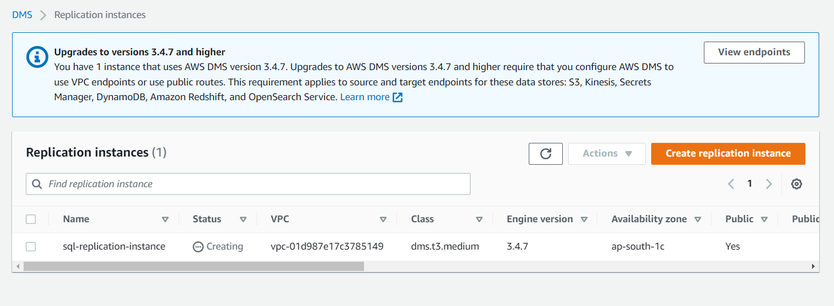

1. Created a source server endpoint using the source server IP (Linux server’s public IP) and tested it.

1. Connected to the RDS from Microsoft SQL Server Management Studio and created a database inside it.

1. Created the destination server endpoint using the RDS and tested it.

1. Create a database migration task.
   1. Selected the created replication instance.
   2. Selected the created source server endpoint.
   3. Selected the created destination endpoint.
   4. Assigned % in selection rules to enable full data migration.
   5. Added tags and created the task.

1. Waited for the migration task to fully complete, then tested using the Microsoft SQL Server management Studio to check if the contents of the on-premises server have been fully transferred into the RDS server on AWS.

*Using the above mentioned steps, I successfully completed the Database Migration Task from on-premises server to AWS.*